VELAMMAL ENGINEERING COLLEGE

AMBATTUR-REDHILLS ROAD CHENNAI

DEPARTMENT OF ELECTRONIC AND COMMUNICATION ENGINEERING .

WEB PHISHING DETECTION (**ASSIGNMENT 2)**

**DATE** : 26-09-2022

**PROBLEM :** PERFORM TASKS ACCORDINGLY

**NAME** : SURTHIKA G

**OUTPUT : SCREENSHOTS:**

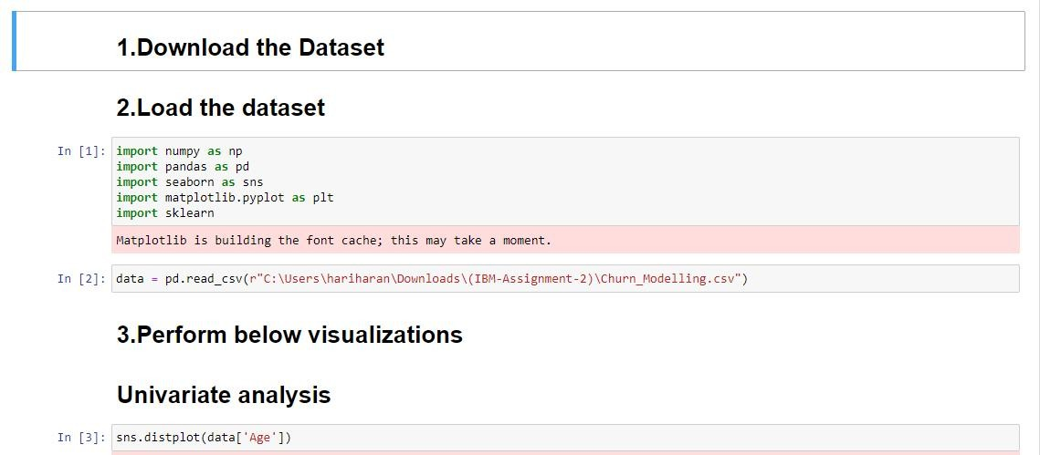

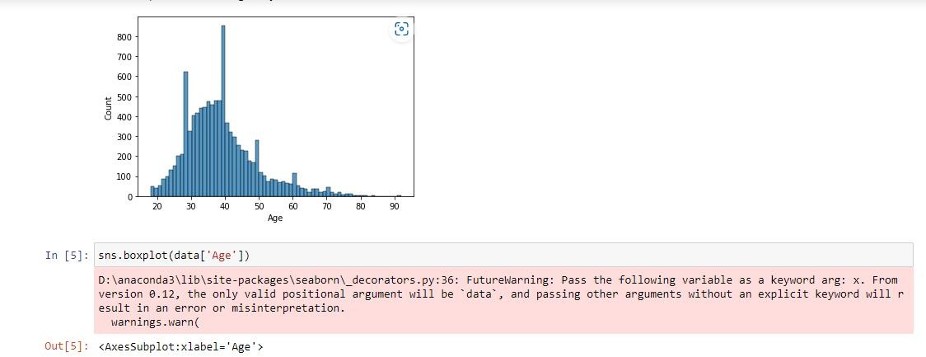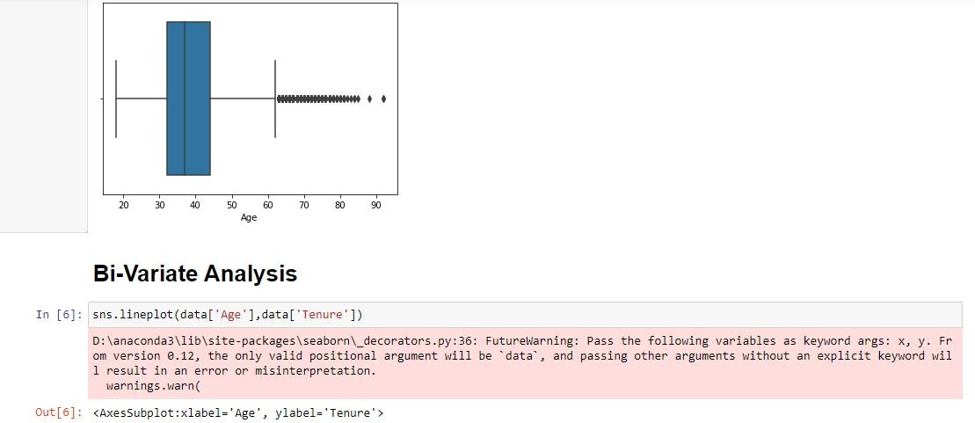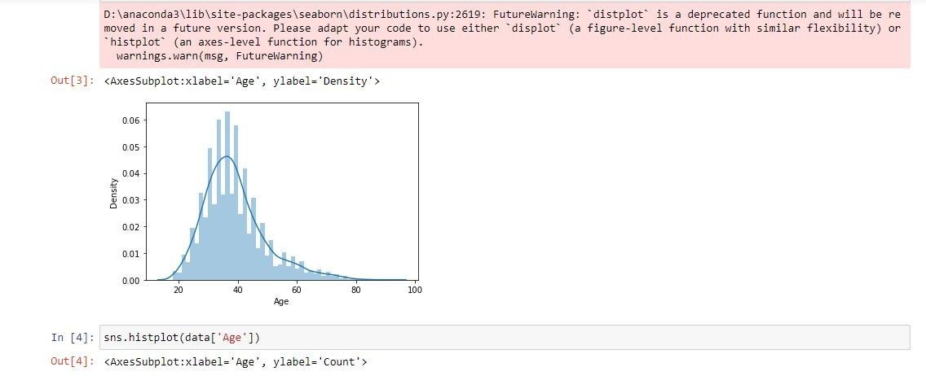

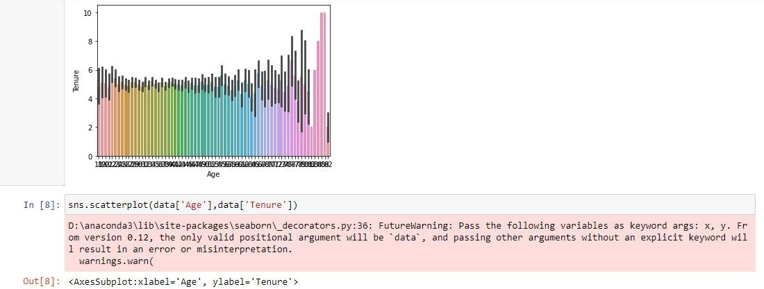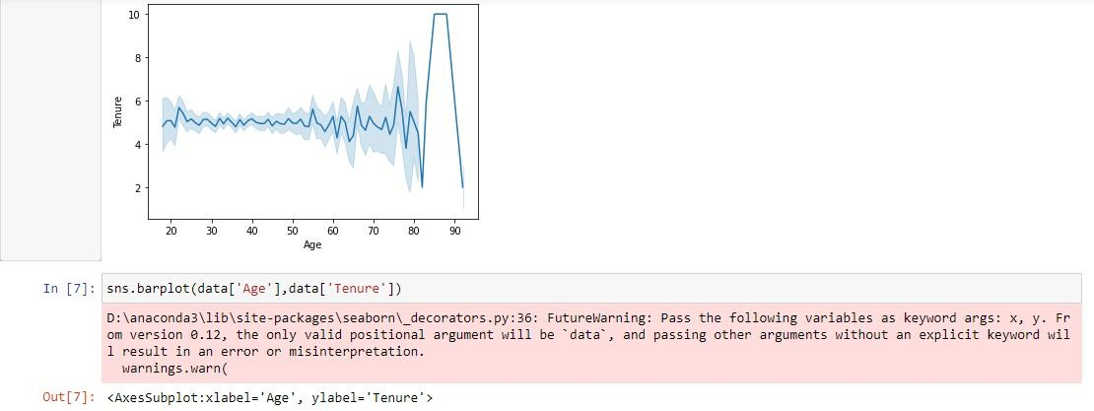

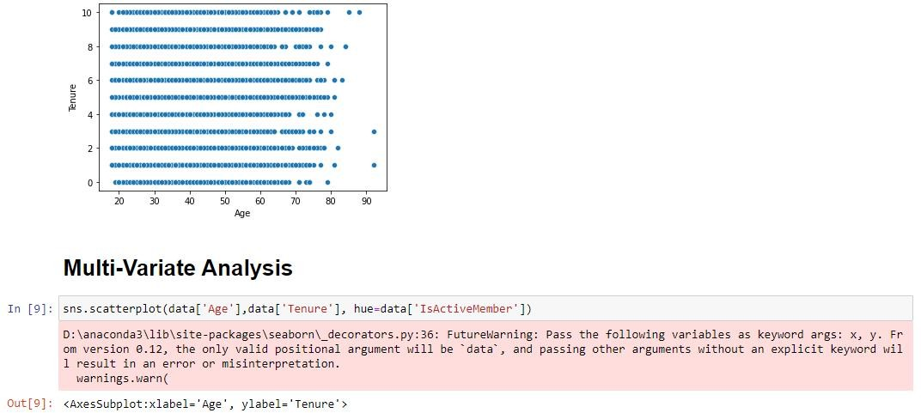

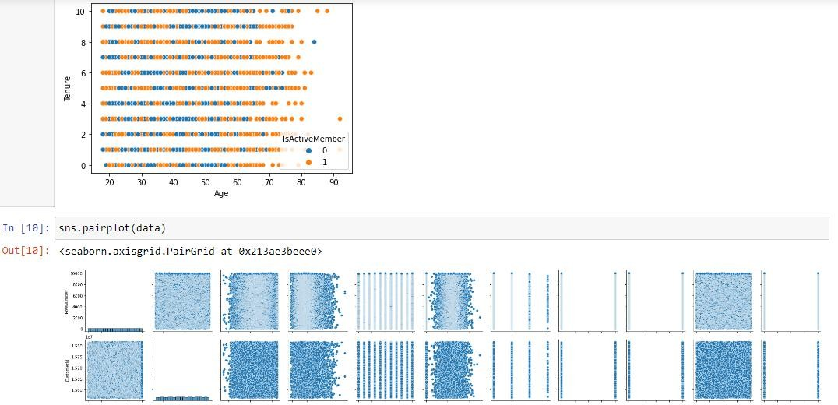

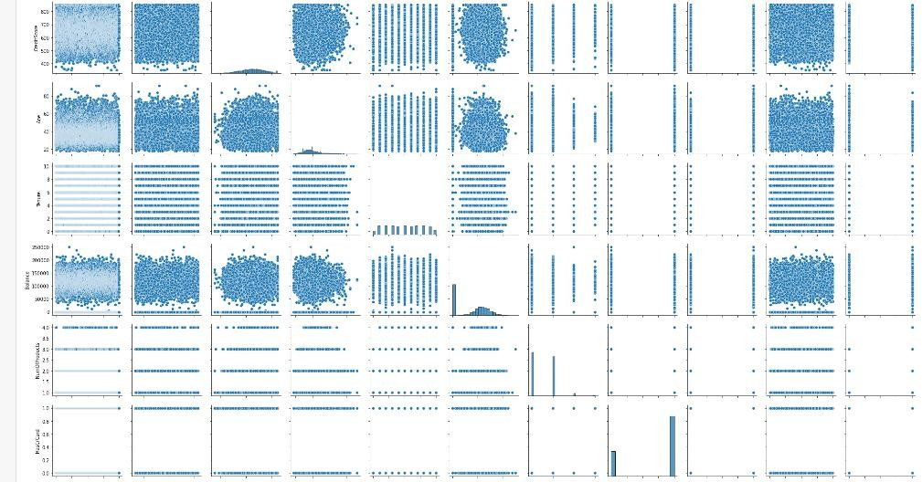

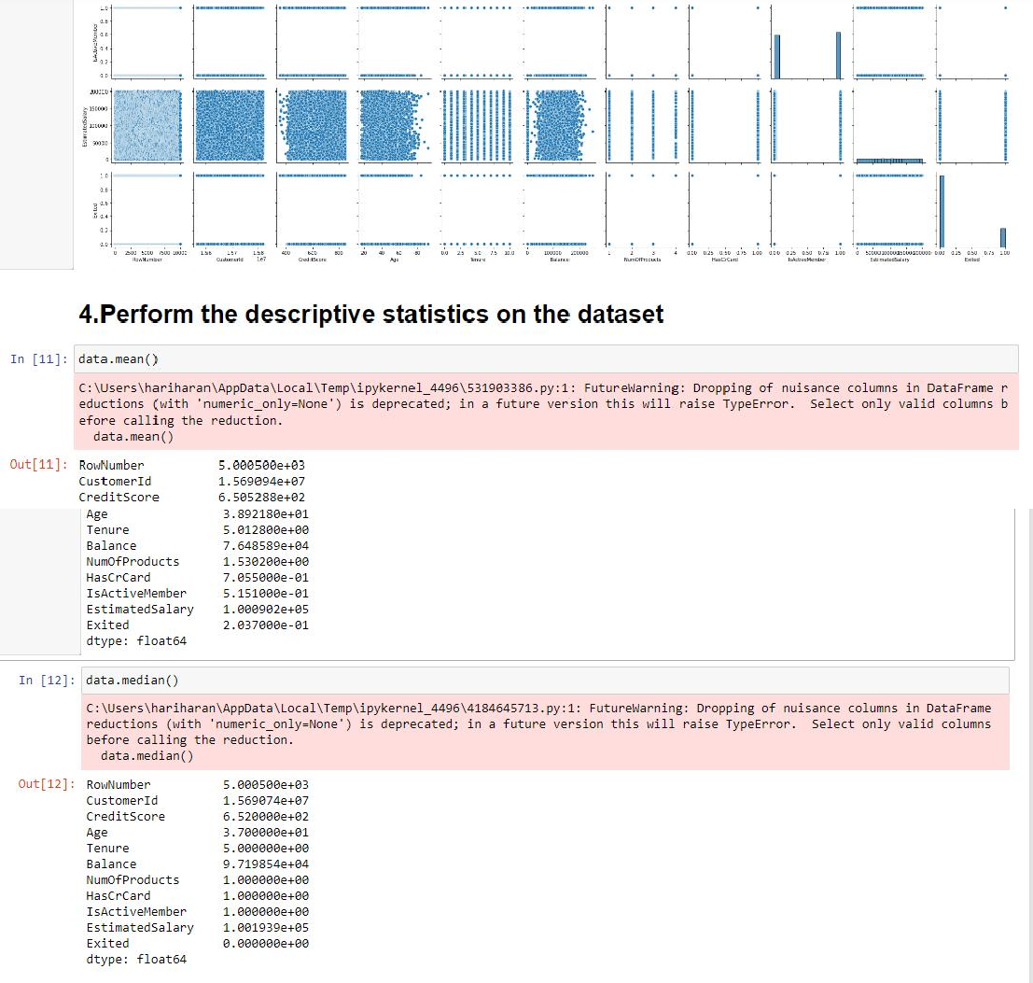

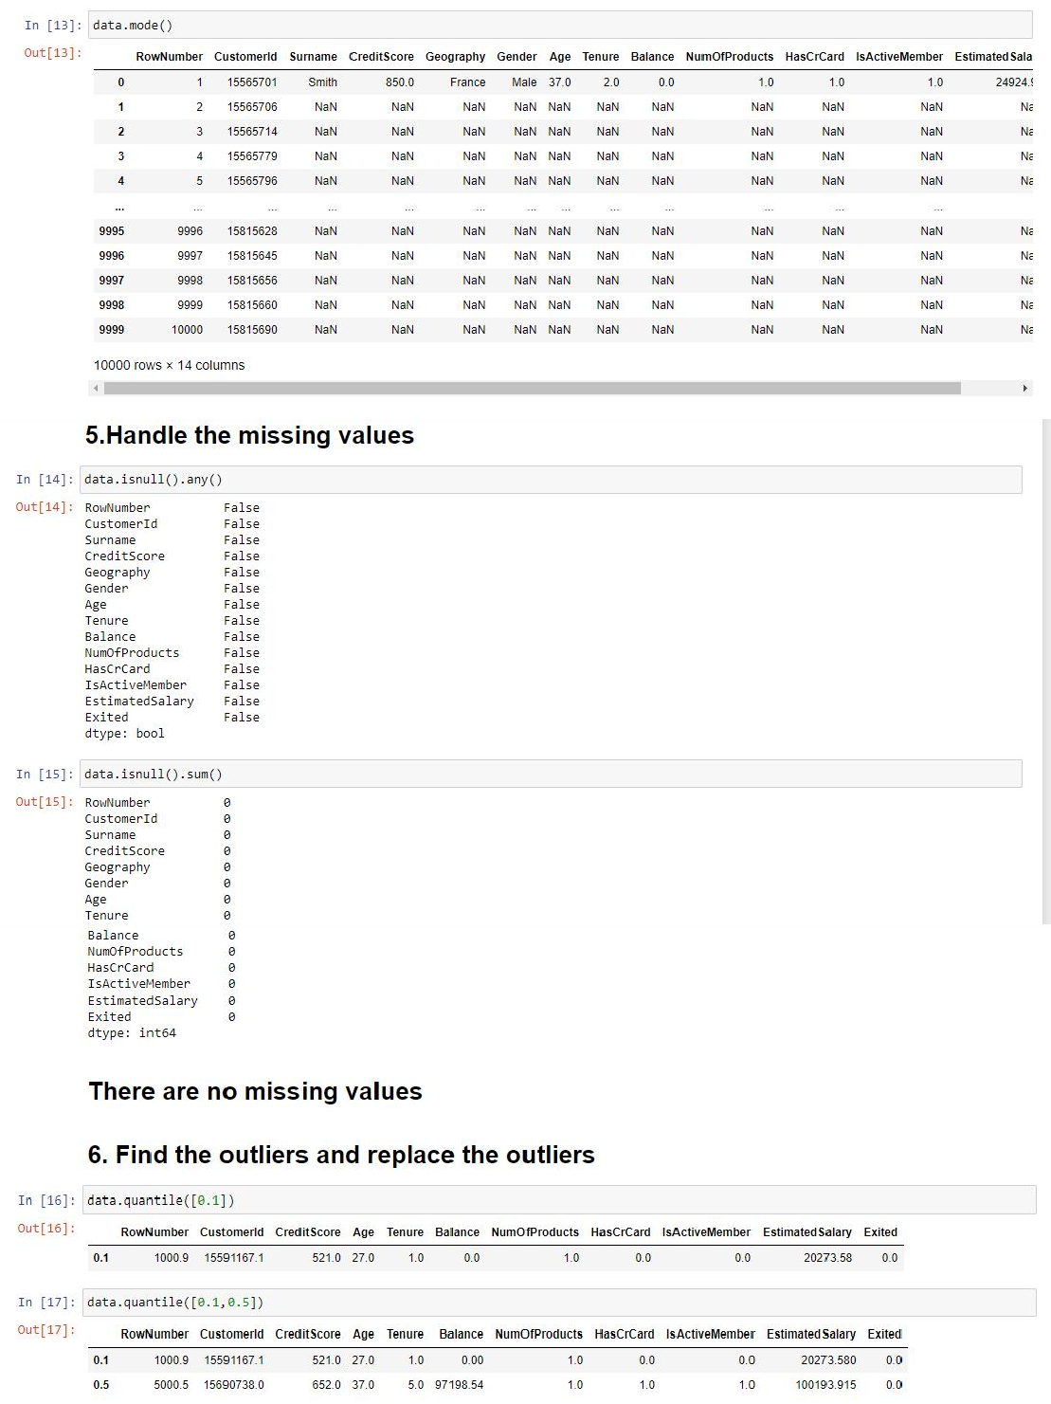

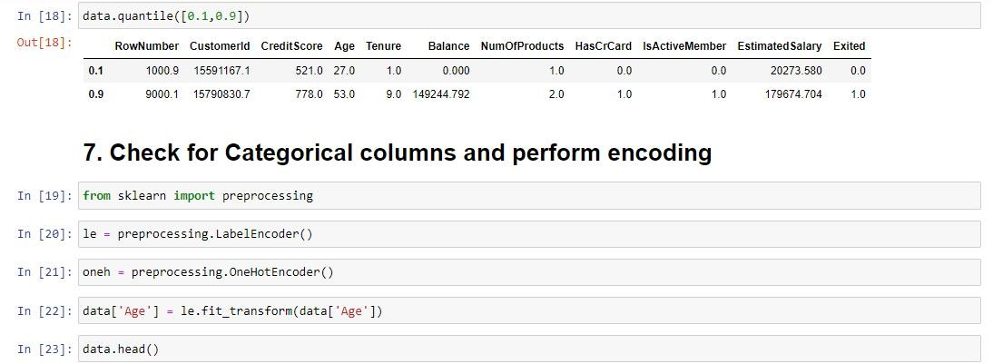

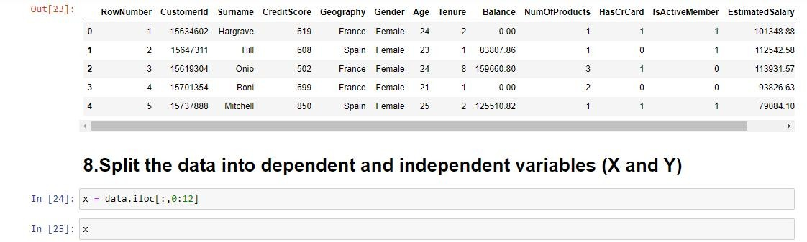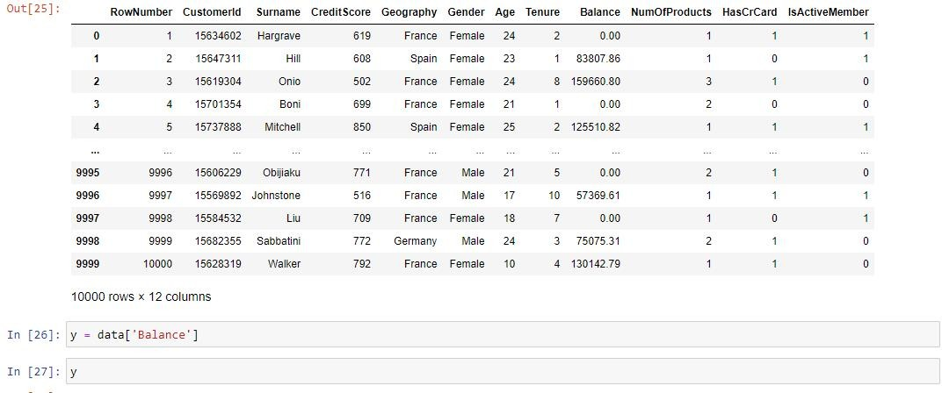

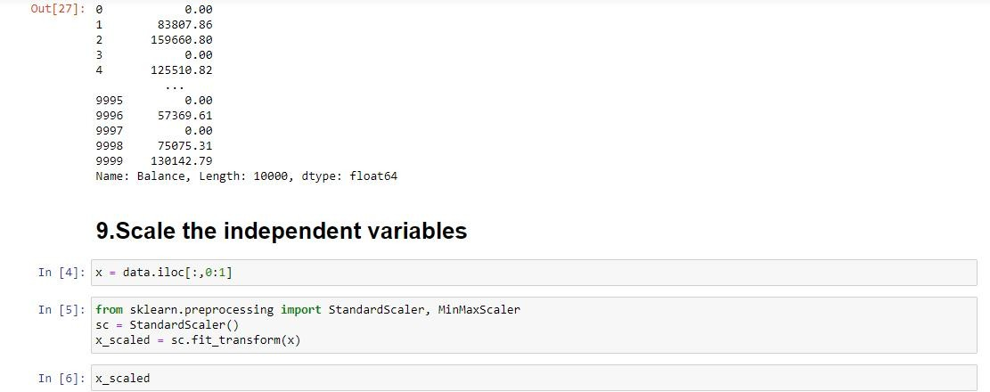

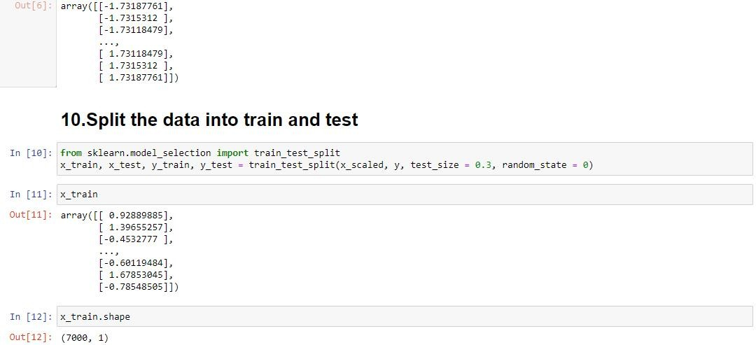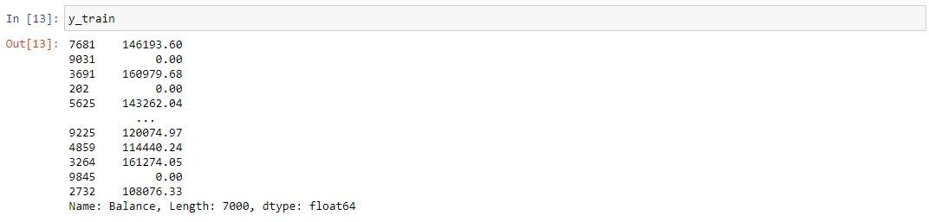

******************************THANKING YOU***********************************